INVOICING GROUP OF INVOICES BY DATE RANGE

Hopefully we have clients that we ship product to every day or even two to three times a day.
A few clients may be overwhelmed by the volume of invoices when each bill of lading creates a separate invoice. Even if invoices are grouped together by purchase order number, the total number of invoices that your customer receives may bury them in paper work. The answer is to send them one invoice for the entire week or even month. The first step is to check the customer field call “Group by Date”. This will create invoices with a status of HOLD, hence the invoice will not print.

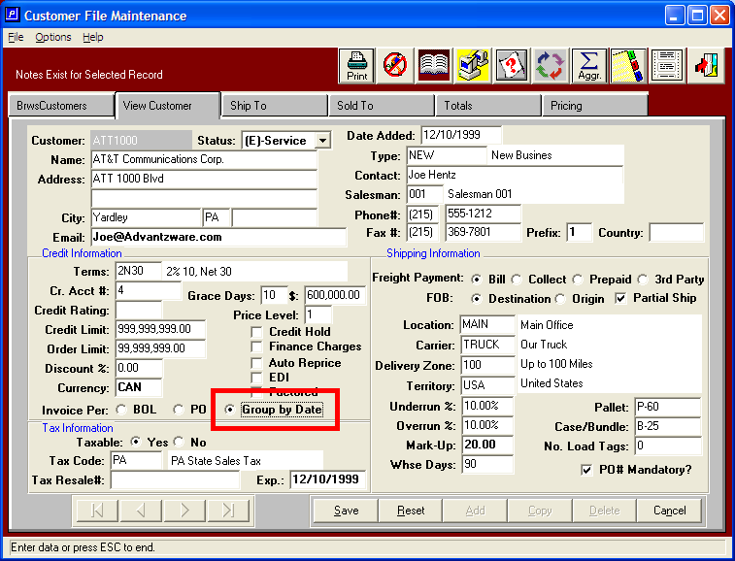

INVOICING GROUP OF INVOICES BY DATE RANGE

In the example below, each bill of lading has created a separate invoice record. However the invoices will not print, because they are on hold.

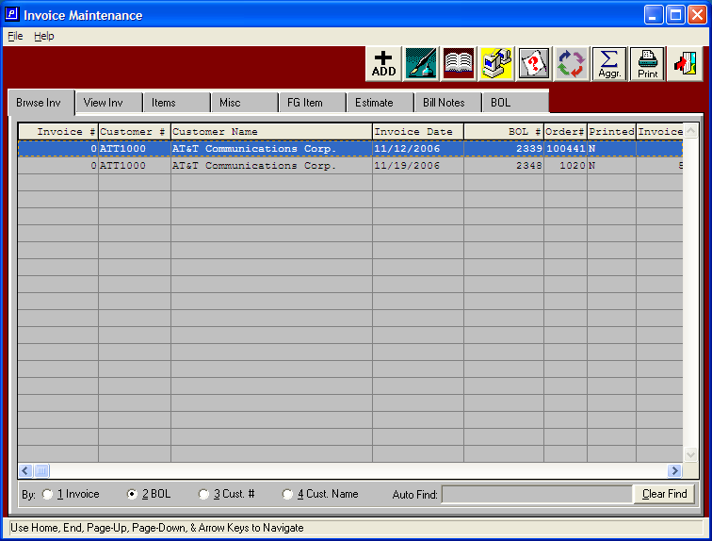
INVOICING GROUP OF INVOICES BY DATE RANGE

Note, bill of lading 2339 which combined multiple orders is created as a separate invoice until printed.

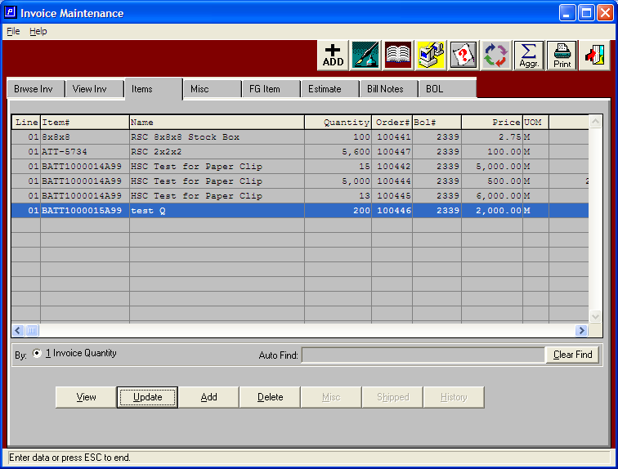

INVOICING GROUP OF INVOICES BY DATE RANGE

Note, bill of lading 2348 which combined multiple orders is created as a separate invoice until printed.

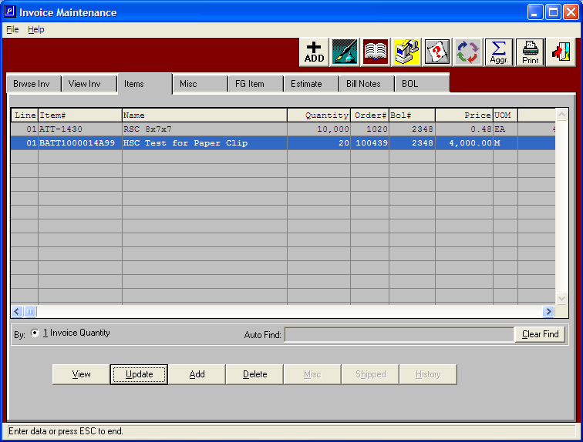

INVOICING GROUP OF INVOICES BY DATE RANGE

Each invoice is created with the status of hold, which stops invoices from printing, hence posting.

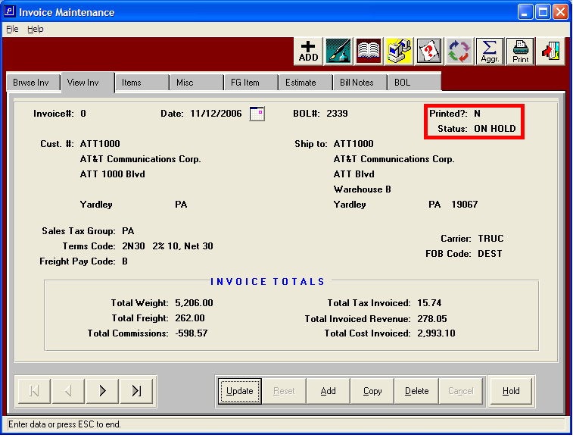

INVOICING GROUP OF INVOICES BY DATE RANGE

Each invoice that should be invoiced for this range should be released by pressing the release button. This will change the status to Release so that the invoice can be printed.

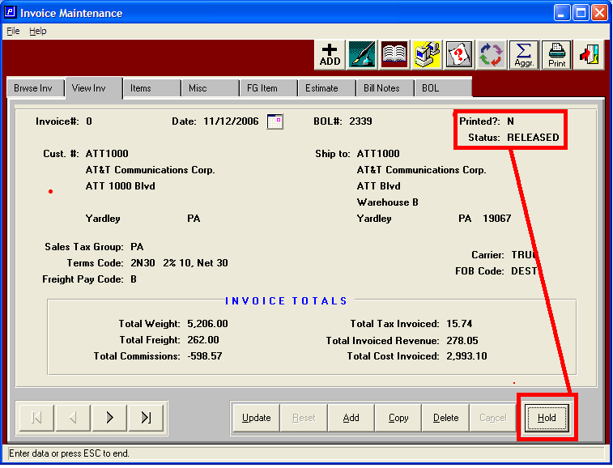

INVOICING GROUP OF INVOICES BY DATE RANGE

After all the invoices have been released, the print menu will combine the invoices by a date range as selected by the invoicing clerk. In the example below, I am printing all invoices for the week from November 12, 2006 to November 19, 2006.

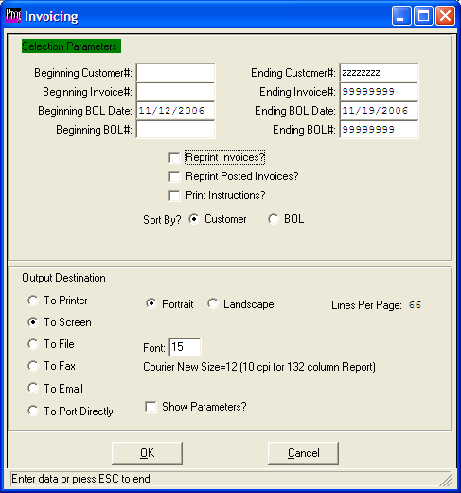

INVOICING GROUP OF INVOICES BY DATE RANGE

As you can see, all the items have been combined onto one invoice. We retain separate records just in case a specific invoice must be deleted.

